1. **Introduction**

The pharmaceutical industry is dynamic, with new drugs constantly being introduced to the market. Understanding the trends in new drug introductions, manufacturers, Wholesale Acquisition Cost (WAC), and their impact on stock prices is crucial for stakeholders in the industry. This report analyzes these insights using data visualizations from a Tableau dashboard.

1. **Target Audience**

This report is intended for stakeholders in the pharmaceutical industry, including executives, investors, and analysts, who are interested in understanding trends in new drug introductions and their impact on stock prices.

1. **Research Questions**
2. How has the trend of new drug introductions evolved over time?
3. What are the key manufacturers contributing to new drug introductions?
4. How does the average WAC at the time of introduction vary by year?
5. What are the top drugs with the highest WAC?
6. Is there a correlation between WAC and stock prices?
7. How do stock prices trend over time for the top manufacturers?
8. What is the relationship between the introduction of new drugs and changes in stock prices?
9. Which manufacturers have the most estimated patient impact?
10. What is the relationship between breakthrough therapy drugs and the estimated number of patients impacted?
11. **Data Cleaning & Processing**

The data provided underwent several cleaning and processing steps in Tableau to ensure accuracy and consistency. These steps included:

* **Data Formatting:** The data was checked for consistent formatting, including date formats, numerical values, and text fields.
* **Missing Values:** Any missing values in the data were identified and either filled in or removed, depending on the context.
* **Outlier Detection:** Outliers in the data were identified and treated appropriately to prevent them from skewing the analysis.
* **Data Integration:** Multiple datasets were integrated to create a comprehensive view of new drug introductions, manufacturers, WAC, and stock prices.
* **Data Transformation:** The data was transformed as needed to create meaningful insights, such as calculating average WAC and stock prices, and aggregating data by manufacturer and year.

By performing these cleaning and processing steps, the data was prepared for analysis, ensuring that the insights derived from it are accurate and reliable.

1. **Visual Analysis of the Insights:**
2. **New Drugs Introductions Trend Overall**

The trend of new drug introductions displays a somewhat cyclical pattern with fluctuations, but there does not appear to be a clear upward or downward trend over the three years. The highest peak is in October 2021, with over 50 new drug introductions. After the peak in September 2020, there is a sharp decline in November 2020, with just 5 new drug introductions.

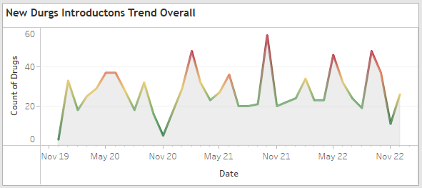

1. **New Drugs Introductions Trend by Top 5 Manufacturers**

The top 5 manufacturers in terms of new drug introductions are Dr. Reddy's Laboratories, Inc., Amneal Pharmaceuticals, Mylan Pharmaceuticals Inc, PureTek Corporation, and Teva Pharmaceuticals USA. These manufacturers have consistently introduced new drugs over the years, with varying levels of activity.

* **Amneal Pharmaceuticals** has a very consistent rise over the three years.
* **Dr. Reddy's Laboratories** has a dramatic increase from 2021 to 2022, becoming the manufacturer with the most new drug introductions in 2022.
* **Mylan Pharmaceuticals** has a steady rise over the three years.
* **PureTek Corporation** had the most new drug introductions in 2021, followed by a significant decrease in 2022.
* **Teva Pharmaceuticals U.** shows an increasing trend from 2020 to 2021 but decrease in 2022.

1. **Top 10 Manufacturers Introduced Most Drugs**

The top 10 manufacturers that have introduced the most drugs include Fresenius Kabi USA LLC, SUN PHARMACEUTICALS, Hikma Pharmaceuticals USA Inc, Zydus Pharmaceuticals (USA) Inc., Pfizer, Mylan Pharmaceuticals Inc, PureTek Corporation, Amneal Pharmaceuticals, Teva Pharmaceuticals USA, and Dr. Reddy's Laboratories, Inc. These manufacturers play a significant role in the introduction of new drugs to the market.

1. **Average Distribution of WAC at the Time of Introduction**

The average WAC at the time of drug introduction has increased significantly over the years, with the highest increase seen in 2022 compared to 2019. This indicates a trend of increasing drug prices at the time of introduction.

1. **Top 5 Drugs with Highest WAC**

The top 5 drugs with the highest WAC at introduction include ABECMA® 250 mL infusion bag and metal cassette, CARVYKTI™, ZYNTEGLO, and SKYSONA. These drugs have high prices at the time of introduction, reflecting their potential impact on healthcare costs.

1. **Correlation Between WAC and Stock Prices**

There is a correlation between WAC and stock prices for pharmaceutical companies, with higher WAC generally associated with higher stock prices. However, this correlation may vary depending on other factors affecting stock prices.

1. **Stock Price Trends Over Time - Top 5 Manufacturers**

The stock price trends over time for the top 5 manufacturers show fluctuations, indicating the dynamic nature of the pharmaceutical industry and the impact of various factors on stock prices.

* **SUN PHARMACEUTICALS**: This company's stock price exhibits the most significant growth among the five. Starting from around 400, it experiences a steady increase over the three-year period, surpassing 1000 by November 2022.
* **Eli Lilly and Company**: Eli Lilly's stock shows moderate and relatively steady growth. It starts just around 130 and climbs to just above 350 by December 2022.
* **Amgen**: Amgen's stock price remains fairly stable throughout the period. It experiences some fluctuations but generally trends slightly upward, staying within the 200-300 range.
* **AbbVie**: AbbVie's stock price begins just under 100 and shows a modest increase over the first two years, followed by a more pronounced rise in the last year, ending just below 200.
* **Novartis**: Novartis has the least variation in stock price among the five companies. It starts just below 100 and stays relatively flat, ending just under 100.

From the graph, we can observe that SUN PHARMACEUTICALS has had a remarkable growth in its stock price, outperforming the others by a significant margin. Eli Lilly and Company, Amgen, and AbbVie also show growth, but at a much slower rate. Novartis' stock price remains the most stable, with very little change over the three years.

1. **Correlation Between Introduction of New Drugs and Changes in Stock Prices**

There is a correlation between the introduction of new drugs and changes in stock prices for pharmaceutical companies. This correlation may be influenced by factors such as the success of new drugs in the market and overall market conditions.

1. **Top Manufacturers with the Most Estimated Patient Impact:**

Manufacturers with the most estimated patient impact play a critical role in healthcare delivery and patient outcomes. Understanding their market presence and product portfolio is essential for stakeholders in the pharmaceutical industry.

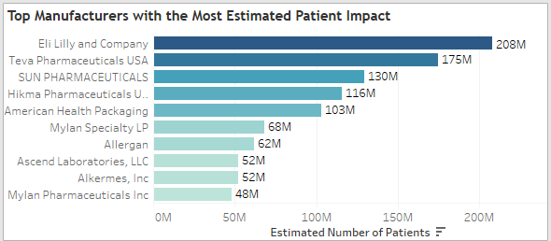

1. **Relationship Between Breakthrough Therapy Drugs and Estimated Number of Patients:**

There is a correlation between the introduction of new drugs and changes in stock prices for pharmaceutical companies. This correlation may be influenced by factors such as the success of new drugs in the market and overall market conditions.

1. **Key Findings**

* The pharmaceutical industry is constantly introducing new drugs, with fluctuations in activity over time.
* Certain manufacturers play a significant role in the introduction of new drugs, with varying levels of activity.
* The average WAC at the time of drug introduction has been increasing over the years, indicating a trend of increasing drug prices.
* There is a correlation between WAC and stock prices, with higher WAC generally associated with higher stock prices.

1. **Recommendations**

* Stakeholders in the pharmaceutical industry should closely monitor trends in new drug introductions and their impact on stock prices to make informed decisions.
* Manufacturers should consider pricing strategies that balance affordability with profitability to maintain a competitive edge in the market.

1. **Conclusion**

The pharmaceutical industry is dynamic, with new drugs constantly being introduced to the market. Understanding the trends in new drug introductions, manufacturers, Wholesale Acquisition Cost (WAC), and their impact on stock prices is crucial for stakeholders in the industry. This report has provided insights into these trends, highlighting the need for stakeholders to stay informed and adapt to the changing landscape of the industry.